**Forecasting Value and Volume using Python**

* **Pre-requisites:**
* Your .py file: Emcure - forecasting-Copy3.py
* Your dataset file (e.g., dataset.csv)
* A computer with internet access
* **Steps:**

1. **Install Python**
2. Go to: <https://www.python.org/downloads/>.
3. Click on **Download Python 3.13.3.**

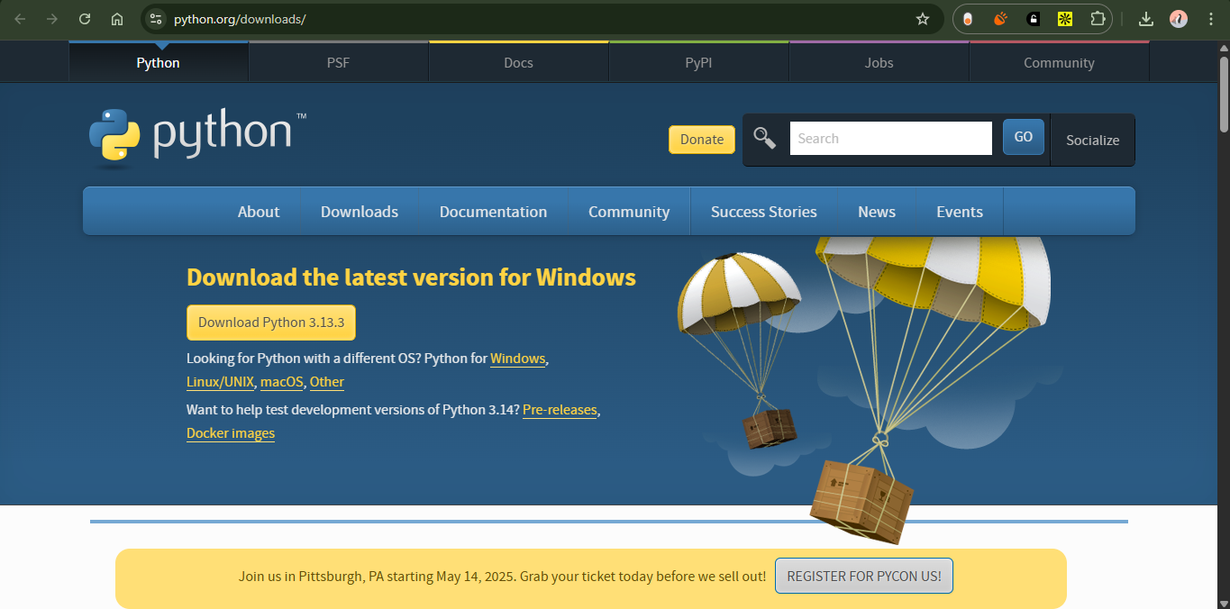

1. IMPORTANT: ✔️ **Check the box “Add Python to PATH”** during setup.
2. Complete the installation.
3. **Install Visual Studio Code (VS Code)**
4. Go to: <https://code.visualstudio.com/>.
5. Download and install VS Code.

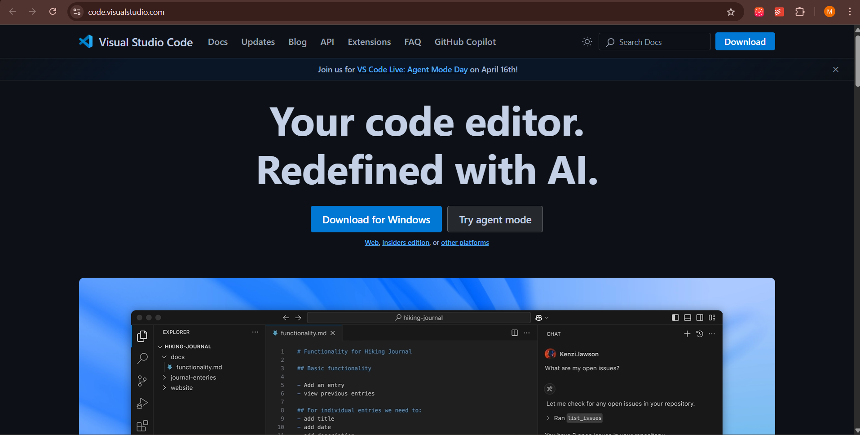

1. **Install Python Extension in VS Code**
2. Open VS Code.
3. Click on the **Extensions** icon on the left sidebar (or press Ctrl+Shift+X).

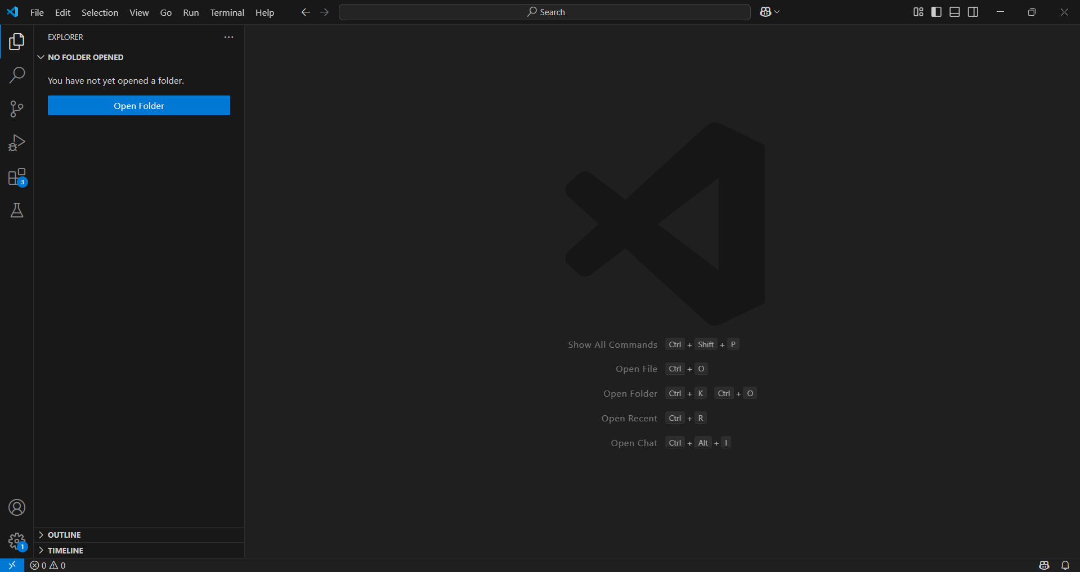

1. Search for **Python.**
2. Click **Install** on the one by **Microsoft.**

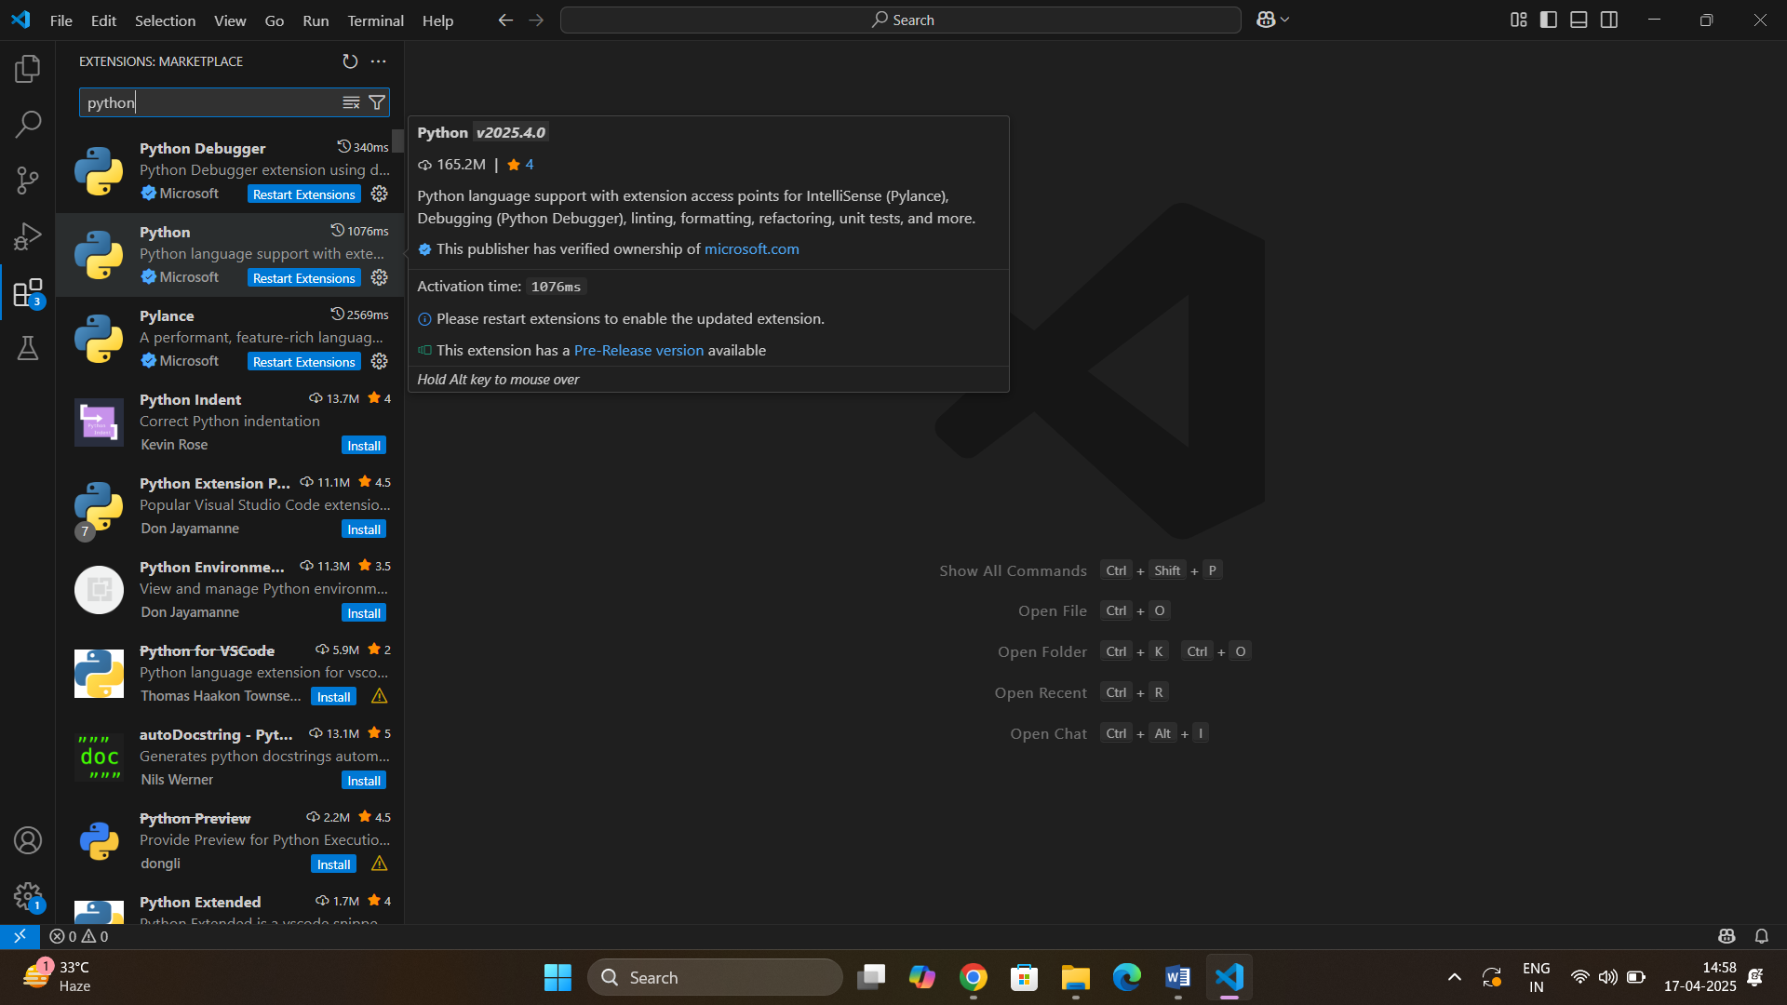

1. **Open Your Files in VS Code**
2. Put your .py file and dataset (CSV) in a folder (e.g., Forecasting).
3. In VS Code, click File > Open Folder and select the folder.

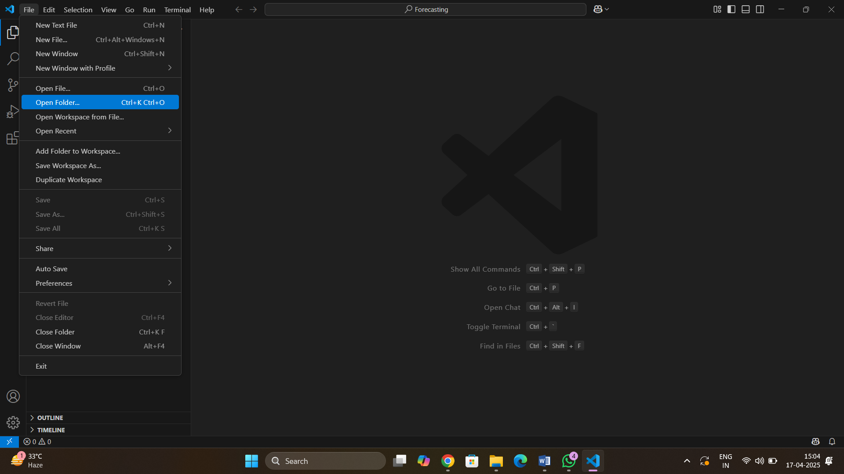

1. After that, you will get something like, now open Emcure - forecasting-Copy3.py by clicking it from the sidebar.

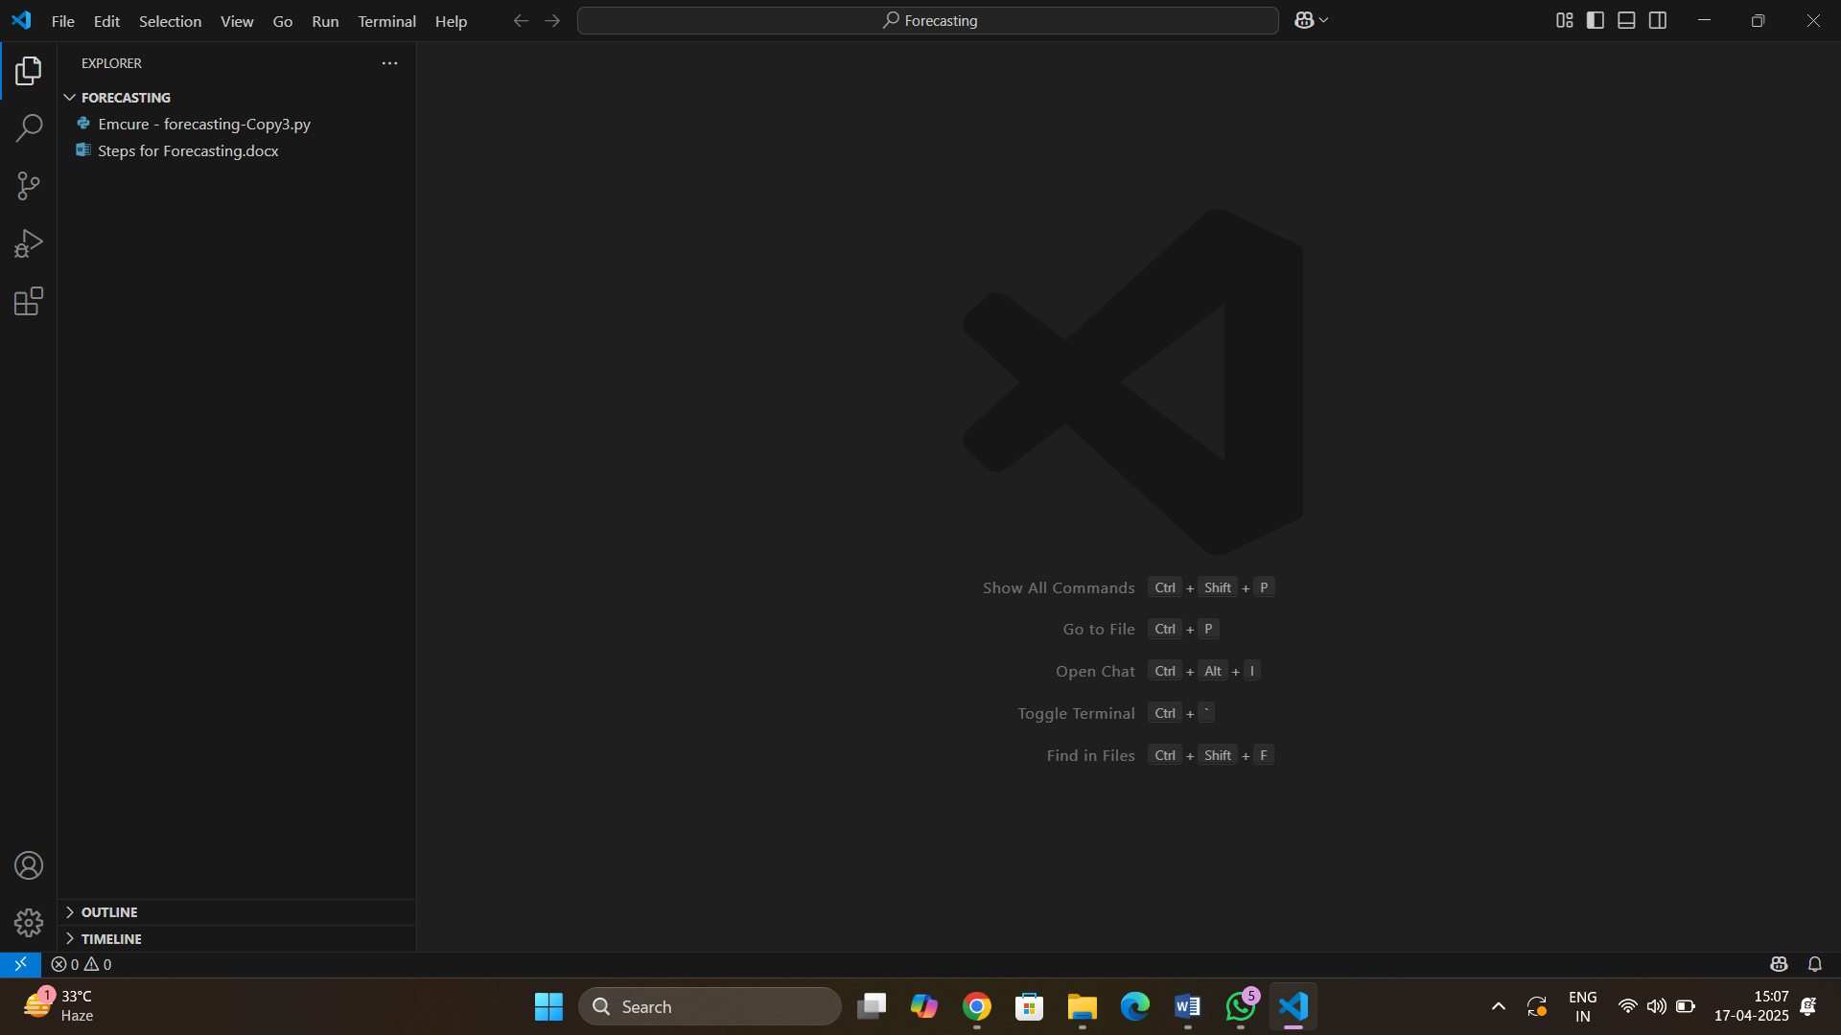

1. **Make the following changes in the code**
2. In **line 65**, change the file_path variable from the given value to the path for the new IQIVIA base file, using **Copy as path** method from the file properties. Let **r** be there as it is.

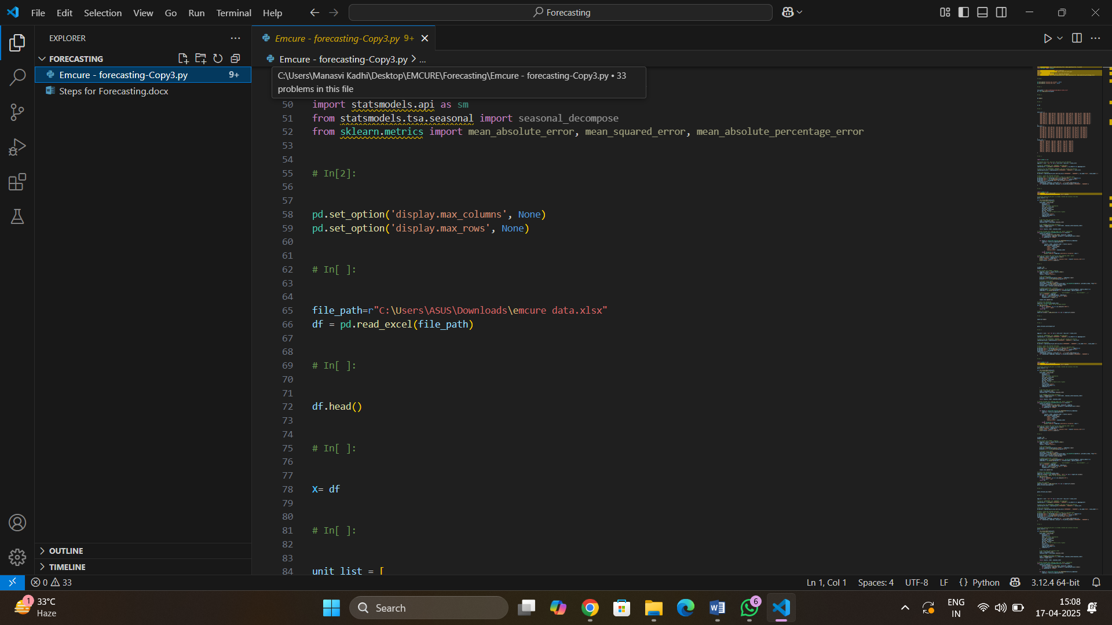



1. In **lines 84 to 119** (where unit_qty, qty_list and value_list is defined), change the first and last months corresponding to the dates in the new IQIVIA base file.

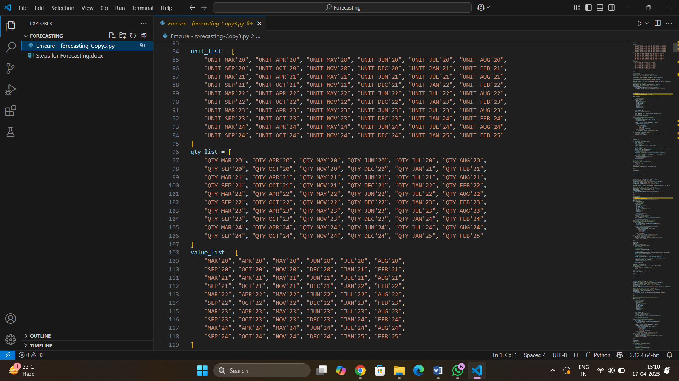

1. Scroll down to the end of the file, in **line 10,321**, change the file_path variable from the given value to the path for the file where the forecasted data is needed, using **Copy as path** method. Let **r** be there as it is.

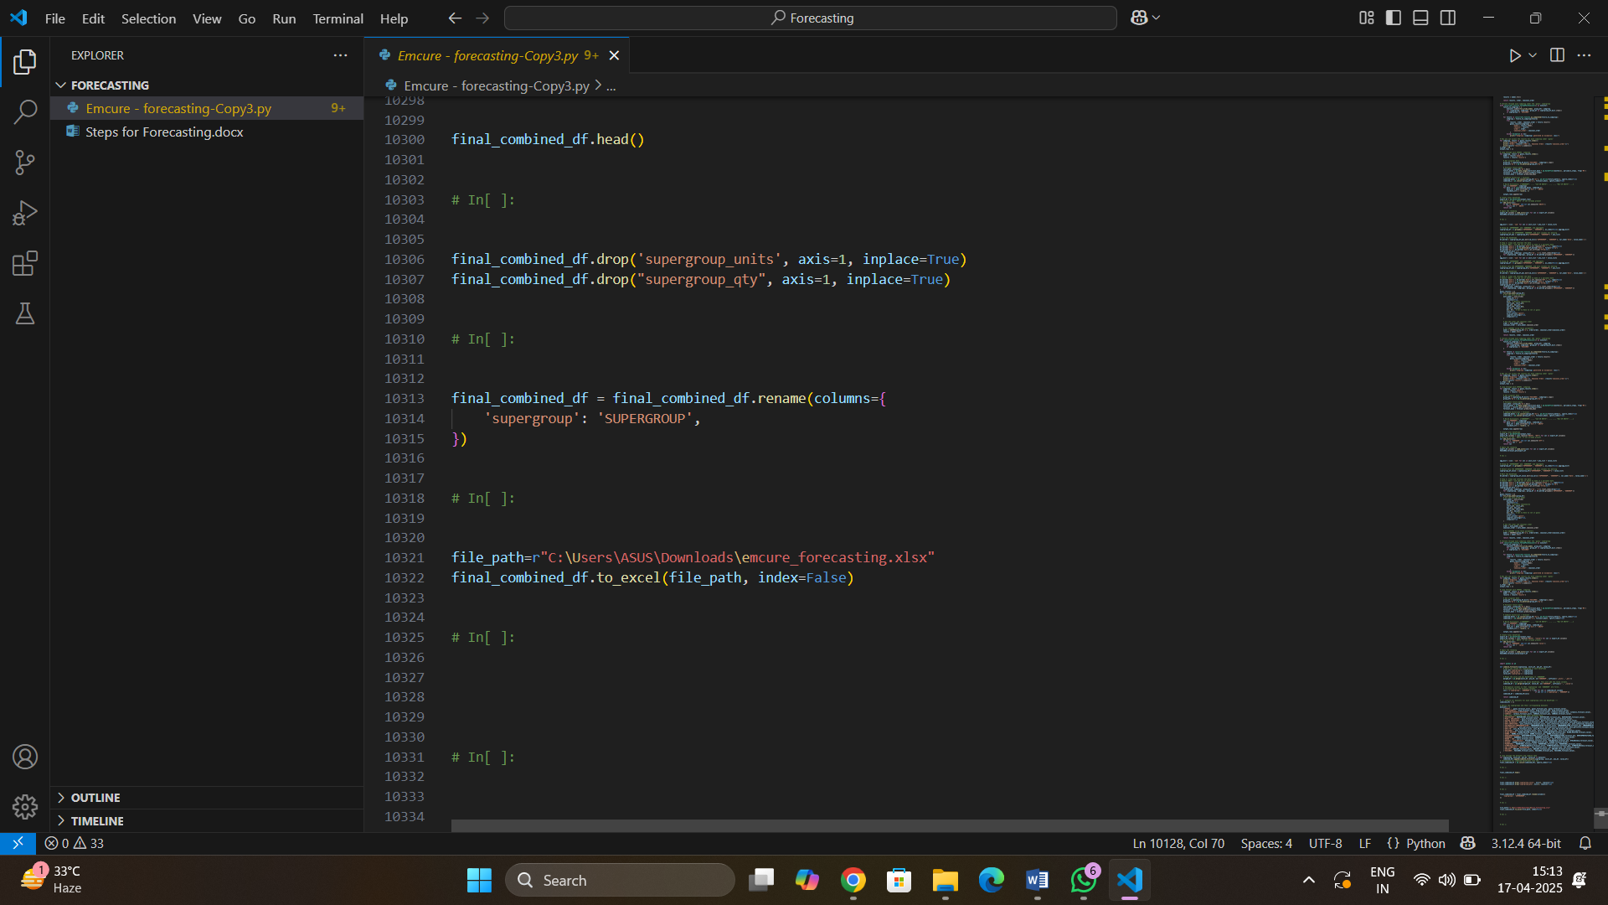



1. **Run the code**
2. To run the code, click the **Run** button (▶️) at the top right.

